Curriculum Vitae
 |  | 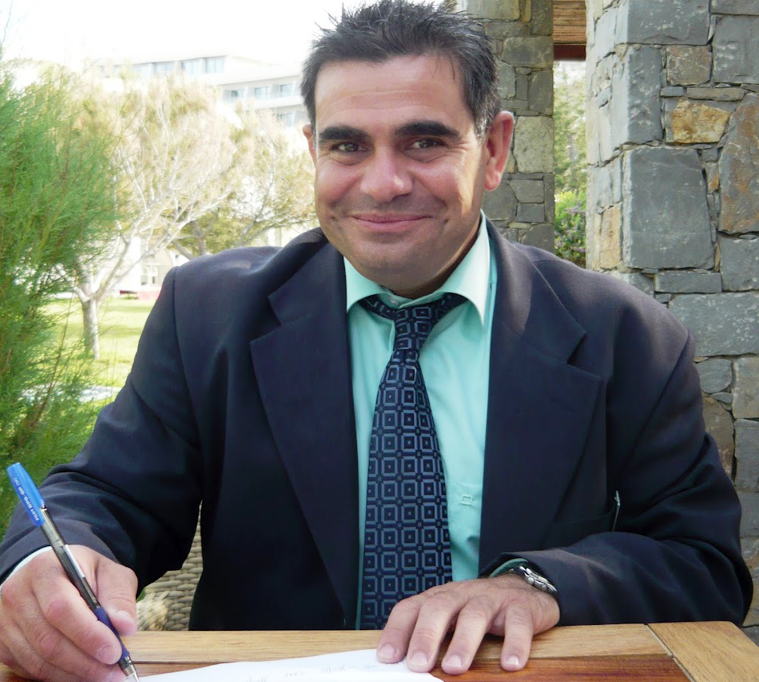
Personal information
First name / Surname |  | Paul MATHIOUDAKIS
Address |  | 5 Mylopotamou St., 71201, Irakleio, Greece
Telephone  Mobile |  | +30 6957 500598
E-mail |  | pavlosmathioudakis@yahoo.gr
Nationality |  | Greek
Date of birth |  | February 4th, 1972
Work experience
Dates |  | April 2010 - TO DATE
Occupation or position held |  | Assistant F & B Manager
Company name |  | Agapi Beach Hotel (Sbokos Hotels Group)
Activity |  | Hotel (4*)
Dates |  | April 2009 – October 2009
Occupation or position held |  | Trainee Assistant F & B Manager
Company name |  | Agapi Beach Hotel (Sbokos Hotels Group)
Activity |  | Hotel (4*)
Dates |  | April 2003 - October 2008
Occupation or position held |  | Lobby Bar Barman
Company name |  | GRECOTEL Agapi Beach Hotel (Sbokos Hotels Group)
Activity  Dates  Occupation or position held  Company name  Activity |  | Hotel (4*)  Hotel (4*)
  May 1999 – November 2002
  Pool Bar Barman
  GRECOTEL Agapi Beach Hotel (Sbokos Hotels Group)
Dates |  | September 1990 – April 1999
Occupation or position held |  | Sales Department
Company name |  | Assargiotakis Ltd.
Activity |  | Wholesale Commerce
Dates |  | August 1989 – August 1990
Occupation or position held  Company name  Activity |  | Sales Department  Mizerakis S.A.  Home decoration & products

Education and training
Title of qualification awarded | Tourism Management Degree  (School of Management and Economics)
Name and type of organisation providing education and training | Technological Educational Institute of Crete
Personal skills and competences
Mother language | Greek
Other language(s)
Self-assessment |  | Understanding |  |  |  | Speaking |  |  |  | Writing
European level (*) |  | Listening |  | Reading |  | Spoken interaction |  | Spoken production
English |  | C1 | Proficient user | C1 | Proficient user | C1 | Proficient user | C1 | Proficient user | C1 | Proficient user
Russian |  | B1 | Independent user | B1 | Independent user | B1 | Independent user | B1 | Independent user | B1 | Independent user
German |  | A2 | Basic user | A2 | Basic user | A2 | Basic user | A2 | Basic user | A2 | Basic user
French |  | A1 | Basic user | A1 | Basic user | A1 | Basic user | A1 | Basic user | A1 | Basic user
 | (*) Common European Framework of Reference for Languages
Computer skills and competences | European Computer Driving License (ECDL)  Microsoft Office Word & Excel (Proficient user)  Microsoft Office Power Point (Independent user)  Microsoft Office Access (Basic user)
Artistic skills and competences | The last 23 years I am a radio producer
Additional information | Seminars:  - Windows, Word, Excel, Internet, Power Point & Access (2012)  - Executive Education seminar and hotel Tourism sector (2012)  - Education seminar to Hotel Managers (2012)  - Russian Language (2012)  - Body language (2011)  - First aid courses (2010)  - German Language (2009)

