
International festival of the museums “InterMuseum-2017”
Moscow, 25 – 29 May 2017
The Central Exhibition Center «Manege» (Manege Square, 1)

The annual International Festival «Intermuseum-2017» is one of the major events of the museum calendar in Russia. «Intermuseum» is unique cultural space invariably attracting not only professionals engaged in museum activity but also a wider range of visitors. The subject for «Intermuseum-2017» is «Museum of the Future»
Background
"Intermuseum" is an annual festival that unites more than 300 Russian and International museums on one platform. "Intermuseum" is a platform for experience exchange, an opportunity for museums to show their achievements. The festival has been organized by the Ministry of Culture of the Russian Federation since 1999. In different years the festival was attended by the Prime Minister D. Medvedev, the Deputy Prime Minister O. Golodets and other political, public and cultural figures.
In 2016 more than 35 000 people visited the festival. The participants were united under the theme "Museum without borders", discussing a museum as a tool in intercultural dialogue. In other years the theme of the festival was also the role of museums in the development of tourism, education or territories. The program of «Intermuseum-2016» attracted the attention of the participants from the foreign museums of Great Britain, Italy, China, Spain, Germany, Finland and France.
The structure of the festival program includes the exhibition of museums, the business and cultural program.
Exhibition. The exposition part of the festival includes more than 200 museums. The biggest Russian federal, municipal, private and international museums present their achievements for the attendees.
Business program. For professionals in the museum sector the festival offers more than 200 professional events organized by the Ministry of culture of the Russian Federation, Russian Committee of the International Council of Museums (ICOM Russia), the Union of Museums of Russia, the Vladimir Potanin Foundation. It will cover volunteer and educational projects, personnel policies, interactive and multimedia technology. The museums participating are the most successful and innovative projects implemented in recent years. Experts from foreign countries will also share their own experience.
Cultural program. The lectures, public talks, concerts and performances are to take place on the central stage of the festival and other venues. The museums will present their best educational programs in the Playground of the "Intermuseum". Young guests of the festival will make scientific experiments and researches, draw together with contemporary artists.

Organisation
The development and support of the cooperation with the foreign colleagues is an important and prospective direction for museums in Russia which is the emphasis of «Intermuseum».
Foreign guests of the “Intermuseum” festival are invited to present their expositions in a space of the exhibition and to take an active part in the business program.
The equipped area of the standard construction is provided on a grant basis to each participant, according to the plan approved by the Organizing committee of the festival. The size of the standard stand is about 10 square meters and equipped with the furniture (a table, chairs, a locker-showcase) (page 5-6). All non-standard additional elements and decorations of the stand are acclaimed but shall be covered by the participant. (If necessary, the festival organizers can provide recommendations for possible cooperation with Russian companies for the rental of furniture and equipment, but in any case do not insist on working with them).
All events of the Festival are free for the participants. The representatives of museums, curators and artists are also welcome to participate in business program with a report or presentation. (The draft of the program is provided on page 3-4).

All travel and accommodation costs for participants of the Festival will be covered by the participants on their own. The Organizers provide an invitation for visa request if necessary.
To participate in the business program, please submit your request to the following address: icom.russia@gmail.com (Dinara Khalikova). For detailed information about the Festival and your participation in exhibition don`t hesitate to contact: intermuseum@rosizo.ru, +7 (499) 110-40-35.
The deadline for applications is 31 March 2017, at 23:59 CET (Moscow) time.

Draft of the Business International Program, Oval Hall

25 May 2017, Thursday

09:00 – 10:30 – Opening ceremony of the Festival

14:00 – 17:00 – Plenary Session “Museums of the future: what kind of an institution do we want for museum specialists and visitors?” (English-Russian translation)

Throughout its long history, a museum has always been one of the fastest growing cultural institutions. Today, due to the coverage of different audiences and high level of attendance, the museum has a huge potential to influence public opinion and set up the agenda in the sphere of culture. In the context of the global changes and high rates of informational development, museums are evolving very quickly. In ten years they will probably be quite different from nowadays ones.
This plenary session is designed to discuss what kind of changes await museums and museum community and what should we do to ensure a better future for the sphere.
- What is a museum today? What role does it play for the society and the state? Who needs museums?
- How have the visitors changed over the past 10 – 20 years?
- Does the museum respond to the needs of the society?
- What are museums striving for: to comply with the global interests or work with local communities?
- In which direction will the museum develop? What will influence this development?
- Who will define new trends in the museum field: museums themselves, the government, business or civil sector?

26 May 2017, Friday

11:00 – 14:30 - Thematic section “Museum work through the prism of digital technologies” (English-Russian translation)

Museum Work through the Prism of Digital Technologies
Digital technologies in museums is not a novel theme but actively discussed. A wide range of technologies cannot be considered as a unified sphere, and the rapid pace of technological development involves museums in new discoveries ... and new debates. Many discussions are focused on finding a balance between digital media and exhibits, between "online" and "offline" – in such a context, the technology acts as a tool, as a powerful and modern instrument for attracting visitors and communicating with them. This session is designed to look at technology as an integral part of the core museum activity. We will reveal that sometimes the absence of digital innovation prevents us from qualitative shifts in the study of museum objects, in the preservation and transmission of heritage to future generations. The world is changing and the way we interact is changing. So is the museum work. The success of the museum in the future is defined by its ability to learn and use the best achievements and the most reasonable solutions.
Within the section we will discuss issues related to the role of digital technologies in heritage documentation, attribution, learning, storage and interpretation of museum objects and collections.

15:30 – 18:30 – Round table talks “Social integration by means of museum resources: practical aspects” (English-Russian translation)

27 May 2017, Saturday

11:30 – 14:30 – Thematic section “Controversial heritage in museums” (English-Russian translation)

Sometimes it seems that cultural heritage bears mostly positive connotations; that it is a manifestation of positive values – truth, wisdom and beauty – inherited from the previous generations. There is, however, heritage with negative connotations telling stories of violence, suffering and injustice. Lately such heritage has become the focus of museological discussions and practical museum projects. While dealing with “difficult” heritage, museum professionals often discover that it is also controversial or “dissonant”, because different contemporary communities have different views on it. What causes the dispute over heritage – controversy hidden in the past or differences in today’s agendas? And how do contemporary museums work with “difficult” and “dissonant” heritage? These are the questions to be discussed at the panel, which follows the theme announced by ICOM for the 2017 International Museum Day: ‘Museums and contested histories: Saying the unspeakable in museums’.

15:30 – 18:00 – Round table and seminar on sociological research in the museum

28 May 2017, Sunday

10:00 – 12:00 – Thematic section “The ecology of culture: museum-reserves and museum-gardens as museums of the future” (English-Russian translation)

12:00 – 14:30 - Thematic section “Technical innovations in the museums: from computers to robotics” (English-Russian translation)

15:30 – 18:00 – Round table “Personnel training and mentorship in the museum”

29 May 2017, Monday

11:00 – 14:30 – Thematic section “Museums and cultural tourism” (English-Russian translation)

The full version of the Program will be provided by mid-April 2017.

Scheme of exposition of participants
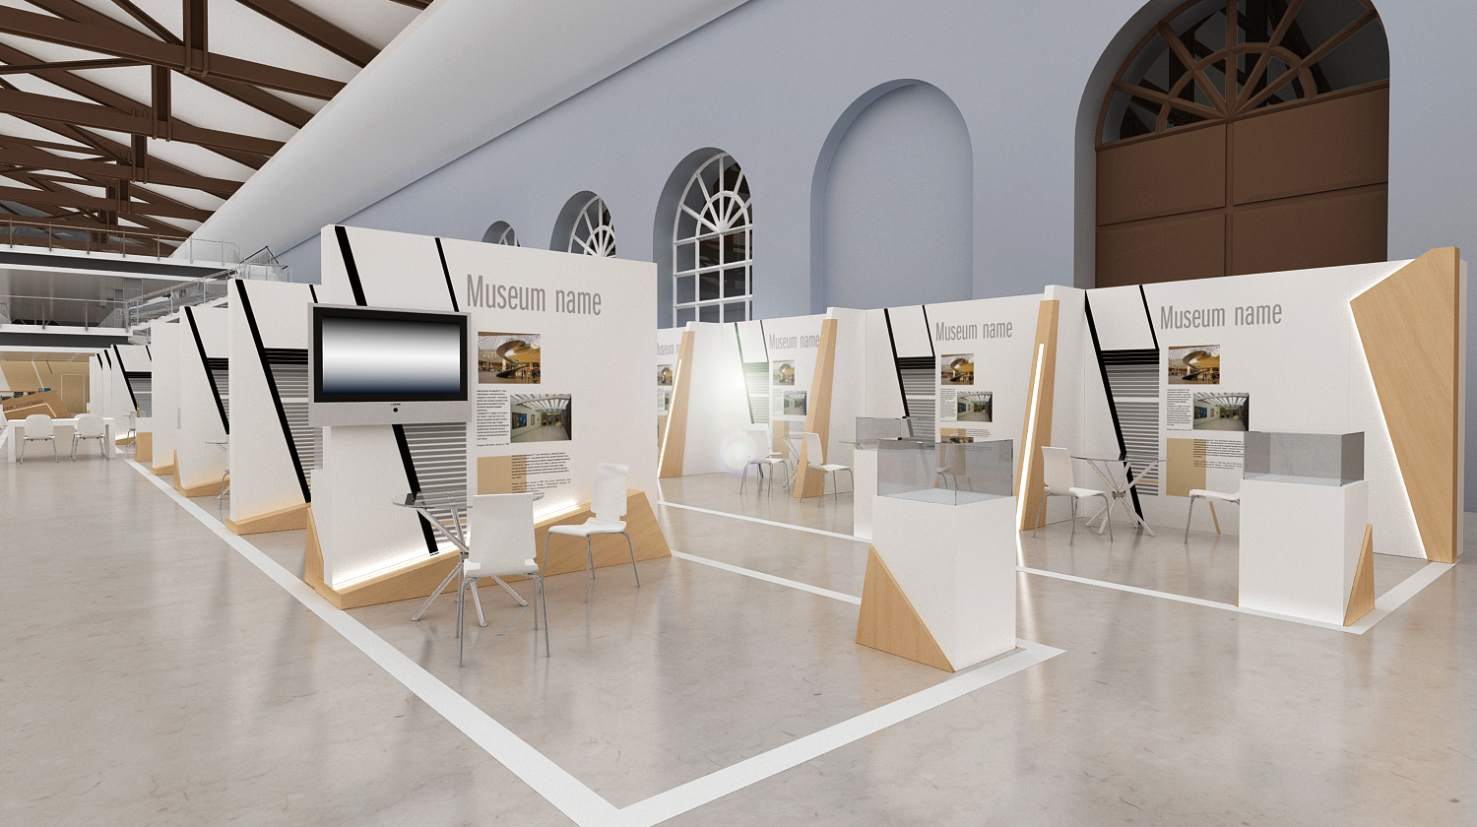
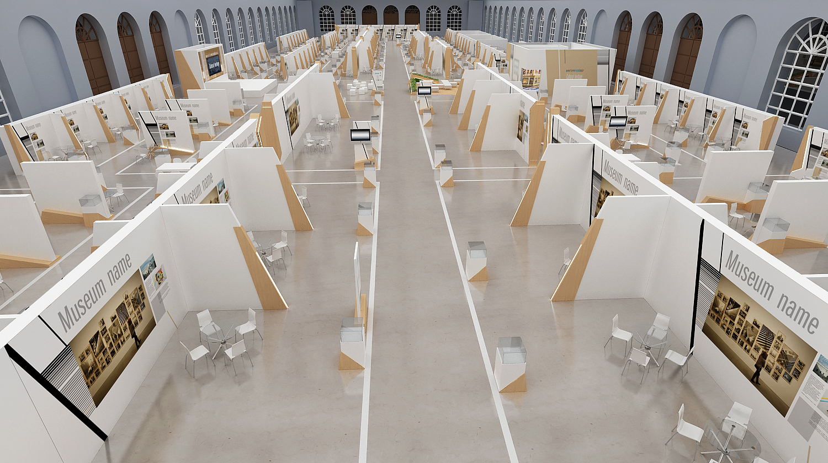
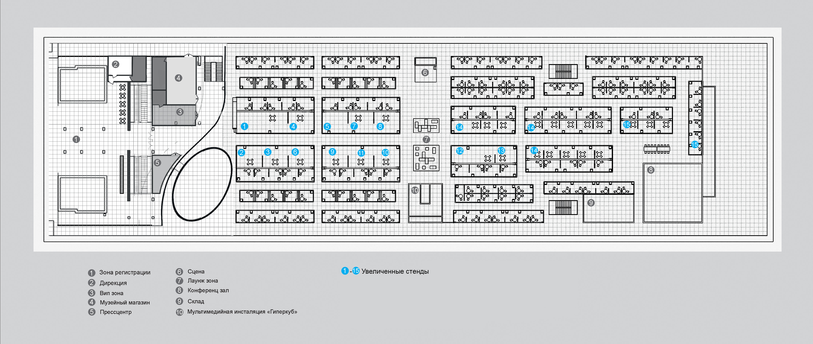

1 – registration zone
2 – the Direction
3 – VIP zone
4 – museum shop
5 – press centre
6 – the stage
7 – lounge zone
8 – conference hall
9 – warehouse
10 – multimedia installation HyperCube
1-15 – enlarged stands

